SDMX GuIDElines

Accessing, retrieving,  
visualising, and Analysing  
SDMX-ML data and metadata files using ms-excel

**January 2020**

© SDMX 2020

[https://sdmx.org/](http://sdmx.org/)

# Introduction

SDMX-ML is basically a format intended for machine-to-machine data exchange processes. Its syntax is thus primarily IT-oriented. However human data consumers may wish to view this information in a more user-friendly environment (e.g. for data visualisation prior to upload to an internal database system).

The aim of this tutorial is to

1. provide a short introduction to web services that allow accessing and retrieving statistical data or metadata files from the websites of national or international organisations which publish their data in SDMX-ML format, and
2. describe in detail how to visualise, manipulate and analyse these data using MS-Excel, probably the favourite individual software among the official statistics community.

Analysts and researchers who want to retrieve and analyse data from different websites are often facing problems of inconsistencies across data sets due to differences in the technologies used, the modelling approaches applied, and the download solutions offered. The above-mentioned guidelines on web services solve such problems by proposing a standardised syntax for web services for data based on the SDMX-ML format. This is a decisive step towards full interoperability of SDMX-based systems.

It should be noted that there are many other software (most of them open source) that can help users manipulate data represented in SDMX-ML format. A list of these software tools is available from the SDMX official website[1].

# Accessing and Retrieving SDMX-ML Data Files

# Introduction

A web service, in very broad terms, is a method of communication between two applications or electronic devices over the World Wide Web. There are two types of web services: SOAP (Simple Object Access Protocol) and REST (REpresentational State Transfer). SDMX supports these two protocols. Web services are an integral part of the SDMX technical standard (Section 7: "Guidelines for the use of web services"[2]).

# Syntax for web services (based on the REST protocol)

The syntax for retrieving a resource using SDMX-based web services is the following:

**http://RootURL/ObjectType/AgencyID/ObjectID/version**

where:

* **http://RootURL/** is the location of the web service entry point of the organisation providing the data or metadata. For Eurostat this URL is <http://ec.europa.eu/eurostat/SDMX/diss-web/rest/>
* **ObjectType** is the kind of resource requested (e.g. dataflow or datastructure)
* **AgencyID** is the maintenance agency for the object requested (e.g. ESTAT)
* **ObjectID** is the identifier of the requested resource (e.g. nama_10_gdp which stands for “GDP and main components: output, expenditure and income)
* **version** is the version number of the requested resource (e.g. 2.1 or latest)

For full details on the configuration of these web services, please refer to the above-mentioned "Guidelines for the use of web services" as well as to the dedicated page on web services on Eurostat’s SDMX InfoSpace website[3].

# Visualising and Analysing SDMX-ML Data Files using MS-Excel

# Reading SDMX-ML data files

The description below is based on MS-Excel 2010; so depending on the version of MS-Excel used, the procedure might look slightly different from the screenshots below. However, the basic functionality remained unchanged since MS-Excel version 2003.

You will find below the SDMX-ML sample file taken from National Accounts table 0101 "Gross Value Added at Basic Prices and Gross Domestic Product at Market Prices", as well as the resulting MS-Excel file.

 

More sample files can be found in the National Accounts package (<https://sdmx.org/?page_id=1498>).

The various steps of the procedure are described below

1. Open MS-Excel, select [File], [Open], browse for the XML file you are interested in (take care not to double-click on the XML file because the .xml extension is usually associated with other applications the MS-Excel and a double-click would therefore launch one of these specific applications).
2. A dialog box will appear; select "As an XML table" and press "OK".

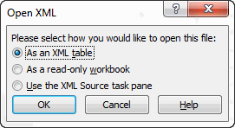

1. The error message below might appear, referring to a schema problem. You can safely ignore this message and click "OK".

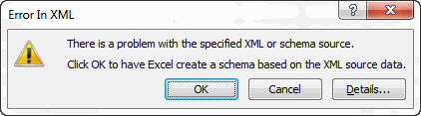

1. MS-Excel then flattens the SDMX-ML file and displays it as a simple table

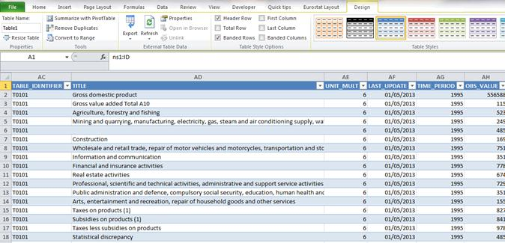

This view is already clear enough to quickly check the figures.

1. In case you want to analyse the data in more detail, especially in the case of large datasets, you can use that table as a basis for the pivot assistant. In the step-by-step description below we reproduced the National Accounts layout but any other layout can of course be chosen. First, click anywhere in the table, go to the "Table Tools / Design" tab in Excel and click "Summarize with PivotTable".

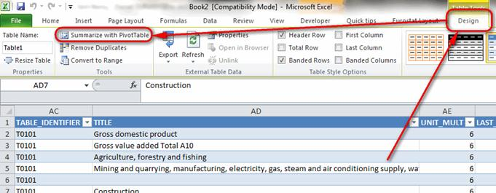

1. Click "OK" in the dialog box.

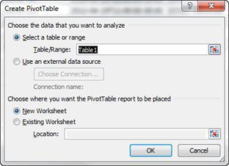

1. You should now be able to drag and drop the fields into the respective areas of the table.

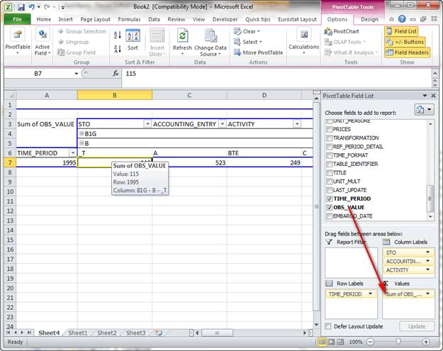

1. With the field settings you can remove sub-totals in order to make the layout look nicer.

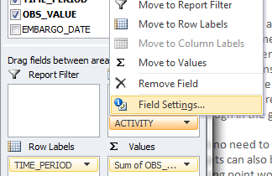 →

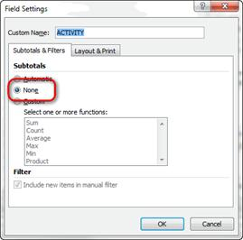

From that step on it is basically playing with Excel pivot to get what you want.

1. <https://sdmx.org/?page_id=4500>
2. <https://sdmx.org/wp-content/uploads/SDMX_2-1-1-SECTION_07_WebServicesGuidelines_2013-04.pdf>
3. <https://ec.europa.eu/eurostat/web/sdmx-web-services/about-this-service>